

CSC-30100 Final Project

Solving First Order Differential Equation

Hasibul Islam | CSC-30100 | 12/31/2018

**TABLE OF CONTENTS**

Introduction------------------------------------------------------- 3

Euler’s Method ---------------------------------------------------- 3

Derivation --------------------------------------------------------- 4

Example ---------------------------------------------------------- 5

Conclusion ------------------------------------------------------- - 6

Reference --------------------------------------------------------- -7

# Introduction

Initial Value problems, also known as Cauchy problems, are problem that involves ordinary differential equations with one specified value. The known value is known as the initial value and we use that value to find the solution of the unknown function. For example we are given an initial value problem y’= f (x, y), y(a)= b. One way to solve this is to find the general solution to the differential equation and then plug in a for x and y for b to get the constant that is generated from solving the general solution. There are a lot of other ways to solve initial value problems. Euler’s method is a numerical method to solve initial value problems.

## Euler’s Method

Euler method is named after Leonhard Euler. His method is the most basic and simplest method to solve this kind of problems. Being so basic and simple comes with disadvantages. One of which is that it’s not the most accurate and optimal way to solve this problems. Since this is an initial value problem we first need to know the initial value. Since we are trying to approximate the shape of an unknown shape with given one starting point and a differential equation, we then find the slope of the curve at the starting point and the tangent line. Then we move a small distance from that starting line and find the slope and tangent line of that point. When you move a small distance the slope of the curve shouldn’t be much of a different than the starting point. If we take a huge numbers of those steps we will be able to have a good approximation of the curve.

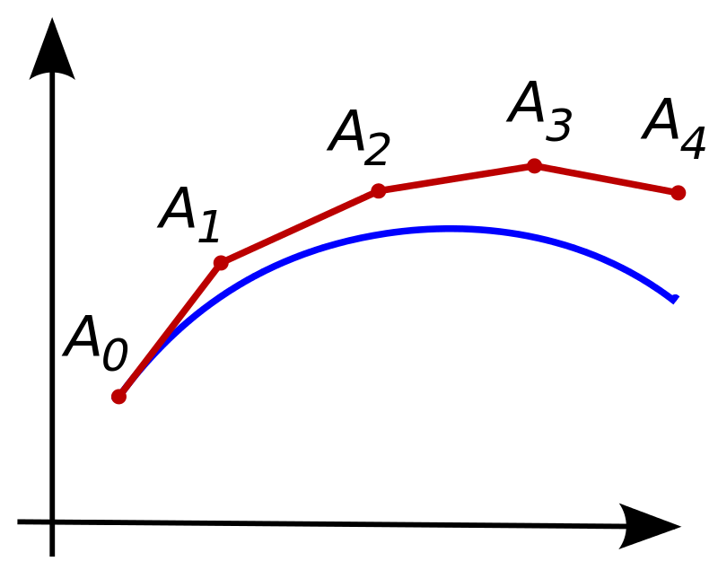

Here we can see using this method to approximate the curve we will get error from the original curve. But still this method will give us a good result if the distance from A0 and A1 is not much and we use a really huge numbers of those steps.

## Derivation

We know that we need to have a specified number of points to approximate the curve. We will then divide the the points in a equally spaced manner. Then the distance between those points will yield to D=(b-a)/N. Where N is the number of points. [a,b] is the range. We can also find the distance between any two points as ti+1-ti. Therefore ti can be equal to ti=a+iD. Where i is 1,2,3,…N.

Using the Taylor series we can derive the the Euler’s method. First we know that Taylor series expansion is y(t + ∆t) = y(t)+∆ty’ (t) + 1 2 ∆t^2 y’’(t) + 1 3!∆t^3 y’’’(t) + ... If we consider y(t + ∆t) as y(ti+1) then we can write as y(ti+1)=y(ti)+ y(ti+1- ti)y’(ti)+( y(ti+1- ti)^2/2(y’’)(Ei) where Ei is some number in (ti, ti+1). We can further substitute D into this sinec D= ti+1-ti. y(ti+1)=y(ti)+ Dy’(ti)+( D^2/2)(y’’)(Ei).

If we substitute the forward finite difference formula we will get

y’(ti )=(y(ti+D)-y(ti))/D Here y’=f(t,y) the differential equation. If we apply the fundamental theorem of calculus now we can integrate the differential equation and get

y(ti+D)- y(ti)=Df(ti, y(ti)). Which is the Euler’s Formula.

## EXample of Euler Method

Let’s apply the Euler Method to v’=2t. The initial value is y(0)=2. If we use D= ∆t=.25 and want to approximate V(1).

We will have the following chart.

|  |  |  |  |
| --- | --- | --- | --- |
| t | V(t) | V'(t+∆t)=2t | V(t+∆t)=V(t)+V'(t+∆t)∆t |
| 0 | 2 | 0.5 | 2.125 |
| 0.25 | 2 | 1 | 2.25 |
| 0.5 | 2.125 | 1.5 | 2.5 |
| 0.75 | 2.375 | 2 | 2.875 |
| 1 | 3.25 |  | 3.25 |

From this we will get V(1) as approximately 3.25. If we analytically solve the differential equation we have the solution as V=t^2+2. From this if we plug in 1 we will have the solution as 3. 3.25 is really close to 3. But if we were to use more smaller ∆t then we might get even closer.

## Conclusion

Although it’s not the perfect method to solve differential equation with given initial value, Euler method is still one of the simplest method. We don’t get accurate values but still are close to the real values. Using a larger N will give us a close to accurate value. But if we were to take the N to infinity we will get a near perfection. There are other methods to solve the initial value problems but Euler method is one of the easiest.

Reference

1. *Newton's Method*, www.ugrad.math.ubc.ca/coursedoc/math100/notes/mordifeqs/euler.html.
2. *Coordinate Systems*, math.oregonstate.edu/home/programs/undergrad/CalculusQuestStudyGuides/ode/first/euler/euler.html.
3. “Euler Method.” *Wikipedia*, Wikimedia Foundation, 20 Dec. 2018, en.wikipedia.org/wiki/Euler_method.
4. Harder, Douglas Wilhelm, and Jesse Rodgers. “Background.” *Topic 6.4: Extrapolation*, ece.uwaterloo.ca/~dwharder/NumericalAnalysis/14IVPs/euler/complete.html.